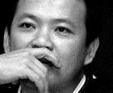**Ng Kim Chew 黃錦樹 (1967–)**

Ng Kim Chew is a Chinese Malaysian author of short fiction and literary scholar who lives in Taiwan. Born in Johor, Ng migrated to Taiwan to attend Taiwan University in 1989. After earning his doctorate from Tsinghua University, Ng became professor of Chinese literature at National Chinan University. Despite residing and publishing in Taiwan, Ng’s short fiction is largely set in Southeast Asia. His stories explore language and literary history, interethnic and religious politics, indigenous and diasporic nationalism, exile, migration and hybridity. As the winner of several Chinese literary awards, Ng’s short fiction is highly ironic, satirical and farcical.

Ng Kim Chew’s modernism parallels the theories of diasporic writing in his literary criticism. According to Ng, ‘Sinophone Malaysian literature’ is the transformation of standard Chinese writing from its cultural, national and linguistic margins. In order to express their hybridity and multilingual background, Sinophone Malaysian authors inevitably grapple with questions of style, form and technique. Ng’s own multilingual play produces strong narrative ironies, tensions, and double meaning. Ng’s collection, *From Island to Island* (由島至島), demonstrates this. The book has a Malay title (*Dari Pelau Ke Pelau*) as well as a different name listed on its spine: *Back Inscriptions* (刻背).

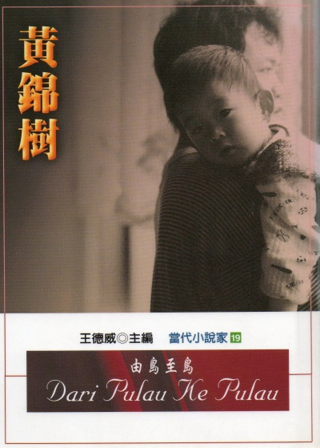

Ng Kim Chew’s short stories confront the legacies of modern Chinese literary influence in Sinophone Malaysian writing. Stories such as ‘The Disappearance of M’ (M的失蹤), ‘A Death in the South’ (死在南方) and ‘Supplement’ (補遺) all recuperate the figure of Yu Dafu (郁達夫, 1896-1945), a renowned Chinese author who came to Singapore in 1938 and was executed in exile on Sumatra by the Japanese military in 1945. In Ng’s stories, Yu Dafu becomes a lingering spectre and object of worship that haunts Sinophone writing in Southeast Asia, imprisoning it in an exilic framework. ‘The Disappearance of M’ also satirizes contemporary literary politics in Malaysia, lampooning not only the Malay-dominated establishment governing national literary production but also ethnocentric Sinophone writers who strive for Chinese linguistic purity in their works. As Ng’s first publication, this story offended many of his compatriots and earned the author the reputation of a maverick.

Ng’s stories hyperbolize obsessions with cultural origins to allegorize diaspora. In ‘Fishbone’ (魚骸), a Malaysian professor working in Taiwan becomes mesmerized by oracle-bone inscriptions as an ancient form of Chinese script. The professor steals turtles from the school’s fish pond, boils them in a school laboratory at night and carves pictographic characters on their shells. The protagonist’s desire to replicate the ancients arouses him to sexual climax. In Ng’s stories, such neurotic behaviour originates with the traumas of colonial and nationalist violence. In ‘Fishbone’, the professor’s obsession is triggered by the discovery of his brother’s corpse in a jungle swamp, likely murdered by counterinsurgency forces during the 1950s. In ‘Back Inscriptions’ (刻背), another Chinese Malaysian professor becomes intrigued by Chinese characters tattooed on the backs of former coolies, only to later discover that the markings were originally the invention of a British colonist who wanted to uncover the mystique of Chinese characters by using the bodies of indentured Chinese labourers as his canvas for linguistic research and experimentation.

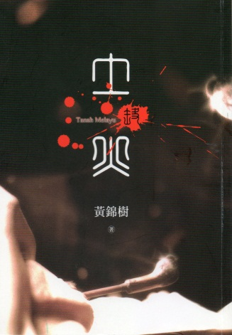Ng’s stories allegorize processes of cultural assimilation. His protagonists are either compelled to or willingly convert to Islam and adopt Malay identities. In ‘The Will of Allah’ (阿拉的旨意), the protagonist is a former revolutionary brainwashed to forget his past during his exile on a deserted island. He becomes alienated from his Malay wife and child when he tries to retrieve his ‘Chineseness’. In ‘My Friend, Abdullah’ (我的朋友鴨都拉), the protagonist converts to Islam and takes a Malay woman as a second wife to enjoy the economic benefits that indigenous status brings. Yet he makes a mockery of the process by continuing to eat pork, drink alcohol and visit brothels.

Ng Kim Chew’s satirical allegories of Chinese settler culture reveal strong affinities to other major diasporic authors of postcolonial fiction, namely V.S. Naipaul and Salman Rushdie. Along with Chang Kuei-hsing (張貴興), Li Yung-ping (李永平) and Li Zishu (黎紫書), Ng Kim Chew has brought Sinophone Malaysian fiction into the purview of world literature.

**Selected Studies of Ng Kim Chew in English:**

Chiu, K. (2008) ‘Empire of the Chinese Sign: The Question of Chinese Diasporic Imagination in Transnational Literary Production’, *Journal of Asian Studies* 67 (2): 593-620.

Uses Ng Kim Chew’s “Fishbone” to critique the privileging of the global city as representative of transnational space in diasporic literature.

Groppe, A. (2010) ‘The Dis/Reappearance of Yu Dafu in Ng Kim Chew’s Fiction’, *Modern Chinese Literature and Culture* 22 (2): 161-195.

Examines the function of Yu Dafu and Chinese literary history in Ng Kim Chew’s fiction.

Tsu, J. (2010) *Sound and Script in Chinese Diaspora*, Cambridge: Harvard.

Chapter 7 considers Ng Kim Chew’s renegotiations of the Chinese literary canon through the figure of Yu Dafu.

Bernards, B. (2012) ‘Beyond Diaspora and Multiculturalism: Recuperating Creolization in Postcolonial Sinophone Malaysian Literature’, *Postcolonial Studies* 15 (3): 311-329.

Examines linguistic and cultural mixing in the work of Ng Kim Chew and others.

**Works Available in English Translation:**

‘Minor Sinophone Literature: Diasporic Modernity’s Incomplete Journey’ (2010), in Tsu and Wang (eds), *Global Chinese Literature: Critical Essays* (Leiden: Brill), 15-28.

‘Sinophone/Chinese: “The South Where Language Is Lost” and Reinvented’ (2013), in Shih, Tsai and Bernards (eds), *Sinophone Studies: A Critical Reader* (New York, Columbia U P), 74-92.

***Chronology of Works:***

**Collections of Short Fiction:**

夢與豬與黎明 [Dream, swine and aurora] (1994)

烏暗暝[Dark nights] (1997)

由島至島 / 刻背 [From island to island / Back inscriptions] (2001)

土與火 [Land and fire: Malay land] (2005)

**Collections of Prose:**

焚燒 [Burning] (2007)